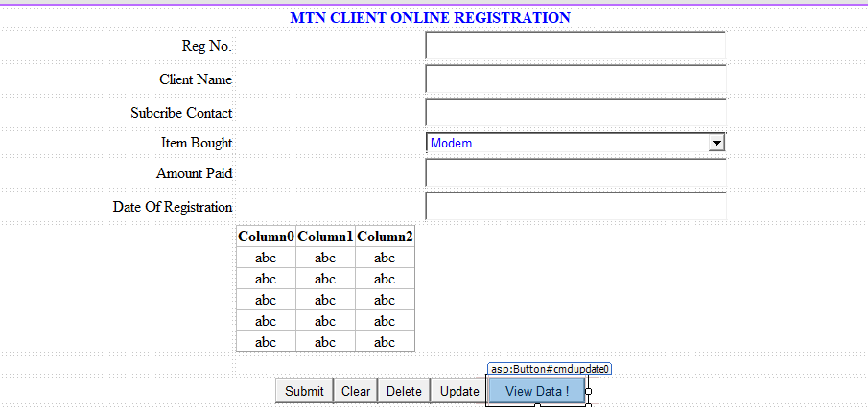

ON THE BUTTON VIEW DATA
Add GridView from toolbox
{
displaydata();
}

private void displaydata()
{

String ConnString = System.Configuration.ConfigurationManager.ConnectionStrings["MtnAppConnString"].ToString();

conn = new MySqlConnection(ConnString);

conn.Open();

queryStr = "";

queryStr = "select * from client";

cmd = new MySqlCommand(queryStr, conn);

cmd.ExecuteNonQuery();
DataTable dt = new DataTable();
MySqlDataAdapter da = new MySqlDataAdapter(cmd);
da.Fill(dt);
GridView1.DataSource = dt;
GridView1.DataBind();
conn.Close();
}

